**Defining Your Probable Future**

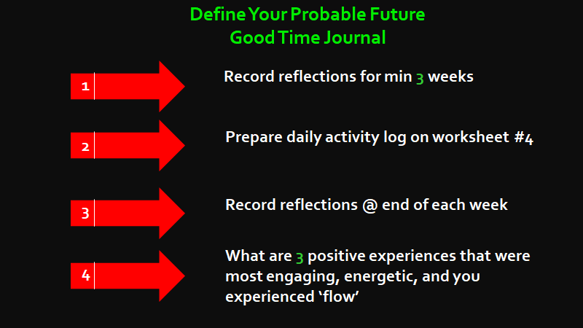

**[ Part 2 – is the problem definition stage in the design thinking process. Instead of defining the problem we define the probable future we wish to seek. We do this by writing a Good Time Journal to gain deeper insight on what actually motivates you.**

**Good Time Journal**

Maintain a journal to record your reflections for a minimum of **three weeks**. The journal comprises daily activity logs and weekly reflection.

**Daily Activity Log**

Record your primary activities, on a daily basis on the worksheet provided.This must be maintained on a daily basis. Record how you feel in each of these activities? Do you feel engaged or not? While doing so, every activity should be evaluated against a gauge indicating the level of engagement, energy and flow as under **(Worksheet #4).**

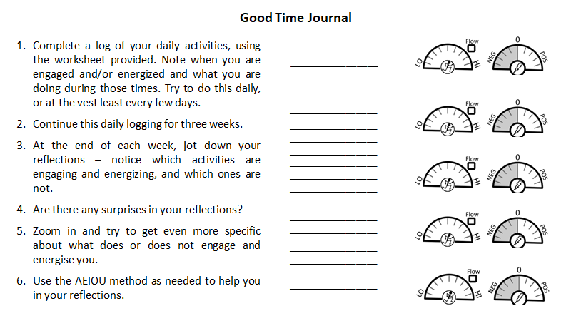

We must figure out which activity motivates you, with as much specificity as possible. This will enable you to evaluate what is and what isn’t working for you. Ask yourself questions like:

* What activities engage and energise you the most?
* What activities make you happy?
* When are you most mindful?
* When do you achieve a state of flow?
* When are you working at your peak level?
* Who else were there , and what role did they play in making it a positive or negative experience?

**Weekly Reflections**

The second part of the Good Time Journal is reflection. At the end of each week write your reflections weekly on blank pages, so that your reflections are based on more than just a single experience of each activity.

Try and identify which activity motivates you, what is and what isn’t working for you. Write also what you are learning – trends, insights, surprises, and ideas on how to improve your routines?

**ASSIGNMENT #4:** What are **3** positive experiences from the Good Time Journal that were most **engaging**, provided you a lot of **energy**, and when you experienced **‘flow’**.

**Individual Ideation**

Ideation is the third stage in the design thinking process to find creative solutions. Brainstorming is the favourite method, and it is done collectively as a team. However, while designing your life, **ideation is done as an individual**, and the technique is called mind mapping. It has the ability to open up space for lots of ideas and come up with many solutions.

The goal here is to brainstorm and not arrive at any decisions. So tap into your imagination and let your mind wander. The mind mapping process has **three steps**:

1. **Mind Map 1 – Engagement**. From the Good Time Journal, select one topic of greatest interest that engaged you the most.
2. **Mind Map 2 – Energy**. Select one activity that energised you the most.

**(3) Mind Map 3 – Flow.** Select one powerful experience when you experienced flow

Thereafter, follow three steps in mind mapping each of the three topics selected.

**Step 1:** Place the experience in the centre of the page and circle it **(Ring 1 – colour One)**.

**Step 2:** Write four or five first things that are related to that idea that come to your mind (random association of words and ideas that come immediately to one’s mind) **(Ring 2 – colour Two)**. Likewise, repeat this process with the words in the second ring. Create **Rings 3** and **4**.

**Step 3:**

* **(1)** Complete one mind map in a maximum of **five minutes**, or else your self-censoring mind will kill creative ideas. As you move outwards genuine ideas will surface from the unconscious mind.
* **(2)** Select and highlight words/phrases from the **outer perimeter ring** of the mind map that resonate with you. Thereafter, mesh them into a few concepts. **Don’t pick from Ring 1 and 2 because these rings are more from conscious thinking.**
* Do this exercise three times – once for each of your mind maps – making sure that each of the three versions are different from one another. **(3)** **From the three mind maps, one idea/concept from each will emerge.**
* **(4)** Create a potential role and job description for you.

It is only natural for the students to ask, what is the purpose of making these mind maps? The whole point is to:

* The student moves out of problem solving (what do I do next) into design thinking (what can I imagine?).
* Defer judgement on getting the right answer right away. Just wait for the process to get over.
* Revisit the maps and see if you can detect good creative options.
* Mind mapping does not aim at generating specific results; it is to ideate without judgement.
* You have got a bucket list of creative ideas (like you do in brainstorming), and now is the time to innovate three real alternative lives.

**4 - Design Your Lives (not Life)**

The life you are living now is just one of the many lives you will most likely be living in your lifetime. The popular erroneous belief is that I need to figure out my best possible life, make a plan, and then execute it. This should be reframed as: there are multiple great lives (and plans) for me, and I get to choose which one to build my way forward to the next.

Research at the Stanford Graduate School of Education has validated, that *“if your mind starts with multiple ideas in parallel, it is not prematurely committed to one path and stays more open and able to receive more novel innovations.” (Page 91, Designing Your Life).*

As a result of the ideation (mind mapping), you have come up with three different options as about your future. Thereafter, create **three** plans for three very different versions of yourself, the next **5 years** of your life. Two/three years is too short as one needs time to build then capabilities also. These three versions may be categorised as under:

**Life One – That Thing You Do**

This is an expansion of your present career. For example, you may be considering upskilling yourself to achieve domain mastery.

**Life Two – That Thing You Would Do if Life One Were Suddenly Gone**

There could be several reasons why your present career may get over suddenly, e.g., health, family circumstances, professional compulsions, Artificial Intelligence, etc. In these circumstances, Life One is no longer an option. What would you do?

**Life Three –** **The Life You’d Live if Money or Image Were No Object**

**ASSIGNMENT #5:** Create **three** alternative **five-year plans**, using the worksheet provided. Keep in mind the following:

* Create a 6-word descriptive title for each alternative.
* Write down three key and relevant questions that each alternative solution is asking.
* Complete gauge on the dashboard – ranking each alternative for resources, your liking, confidence to pull it off and coherence.



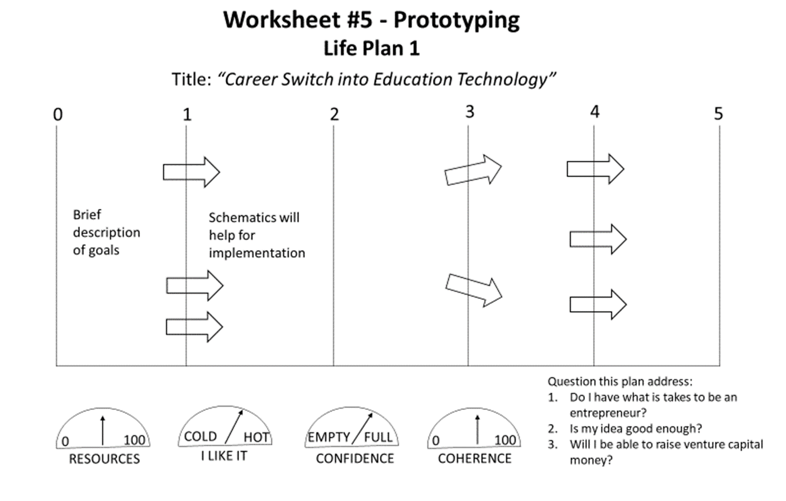

Do not consider these asPlan A , Plan B and Plan C. While you plan for the preferred.

**Prototyping**

The biggest mistake anyone can make is to jump into the idea without prior validation. As Adam Grant writes in *Originals:*

*“The most successful originals are not the the daredevils who leap before they leap. They are the ones who reluctantly tiptoe to the edge of a cliff, calculate the rate of descent, triple-check their parachutes, and set up a safety net at the bottom just in case.”*

Prototyping is a process for testing your chosen life path, and is an essential part of design thinking. In designing your future not much reliable data is available. However, we can reduce the risk by **testing** our ideas, and receiving effective **feedback** and **lots of data.** We do this by **learning from others** who are actually living the future you desire.This is necessary, because actually trying out something before you know what the result might be, is essential, so that you get a timely reaction to it.

Good prototypes are physical experiences that provide data to make informed decisions. Prototypes are useful in **(1)** **asking good questions** and get the data you are interested in; (2) **visualising alternatives** in a very experiential way; **(3)** **reducing risks** in time and money; **(4)** enabling you to see the **blind spots** in your ideas; **(5)** allowing you to **fail and learn quickly**; and **(6)** **sneaking up on our future** someone is already living, a future that is already out there, a future you are interested in exploring. Find them and talk to them.

**Why we Prototype**

* Ask good questions and get data about what you are interested in
* Visualising alternatives in a very experiential way
* Reduce risks – time and money
* Identify blind spots in your ideas
* Fail early and fail forward
* Sneak up on our future

While in product design there are several methods, in life design, we have only one prototyping mechanism. We rely heavily on **role play**. There are **two** ways to prototype – prototype conversations or life design conversation, and prototyping an experience, and they are really different.

**Model 1 - Life Design Conversation**

This model aims at learning from the experiences of someone who is already doing something you are interested in, who is already living the preferred future you are planning to do. The person also has the expertise to answer your questions. You can do it by an inspirational interview; casual coffee; chat after a workshop; or at the bar.

Some of the questions that you should be asking are:

* How did the person arrive at that job?
* What is it s/he loves and hates about the job?
* What all does it involve?
* What opportunities in life and at work did it throw up?

Conversations help in building confidence; and deciding to pivot in case it does not lead you in the right direction.

**Model 2 - Prototype Experiences**

An experience will tell you what a conversation can’t do. But both are important mechanisms to prototype your way into the future. You want actually to experience what “it” is really like. You could do it by volunteering hands-on work; a month-long un-paidinternship; shadowing a professional whose job you might want to do one day; and brainstorming experiences.