**Attachment 1 – Your Higher Purpose**

The great American writer Mark Twain once said: ***“The two most important days in life are the day you are born, and the day you discover the reason why.”***

Everything on this planet that is living, is here for a certain reason, for a certain purpose. Human beings, nature, animals, all have a purpose. If you accept this idea, you will begin to understand that, **because there is life, there is purpose**; and **because there is purpose, there is reason for you to live** - why you have been given this life, and why you are here. Otherwise, it makes a nonsense of whatever God, Guru or religion you believe in.

***“The mystery of human existence lies not in just staying alive, but in finding something to live for.”* ( Dostoyevsky)***.* Those who survived in the concentration camps are of Dachau and Auschwitz, were not the young and the strong, but those who had something to live for.

Just having money, power and creativity, are not enough. Above all you need to be happy. For me that is the highest human aspiration. To bring your brilliant and daring ideas to make a difference, and to be happy, you need meaning and purpose in your life – **why you are here** in the first place; and what is **that something** that life expects from you?

Your purpose is your ***“reason for existence”***. The purpose will bestow upon you the following great edge throughout your life. It is your life’s trump card!

A life, therefore, without purpose is meaningless.

Life by itself cannot explain why we are here in the first place? We have to find answers to the **Big Questions** of life: ***What does life expect from me?*** Or, **what is it that I can give to life?** To answer this question honestly, we must pause, expand the question, and introspect. Your responses should briefly address each of the following questions in **30** words and reach the CEO by **25 November 2022.**

1. *In all my years so far, what have I achieved that I can give back to society?*
2. *What can I take into the world and make it a better place, and myself a better person?*
3. *What is it in society that needs to be ‘fixed’ / repaired / healed? What is it that makes me unhappy, dissatisfied and restless?*
4. *What is it that I can do with this one precious life I have?*

**Attachment 2 – Life Design Assessment**

The **second** step in designing your future is to **start where you are**; not where you think you are, or you wish you were. And not where you think you ought to be. A **life design assessment** to know where you are will be necessary. Break this down into four main areas of your life, and gauge them from empty (zero) to full (100): one’s higher **purpose; meaning at work; emotional health;** and **love** (relationships, with family, and what precious sacrifice you are ready to make). The dashboard will help you to identify what areas of your life need immediate attention. These should be prepared in the form of a dashboard as under:

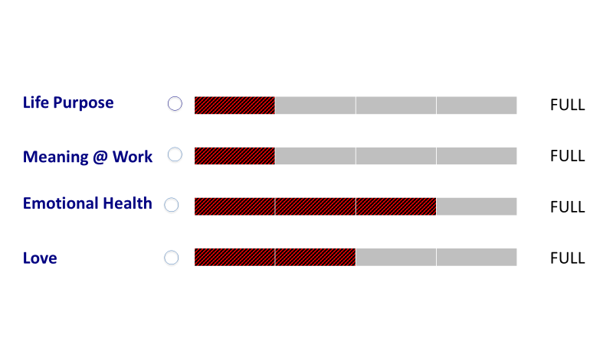

This self-assessment will help you to identify the red zones in your present life, and reflect on what steps should be taken to fill the dashboard?

Write a **50-word amplification paragraph** below each of the above categories. For example, under love you should consider the quality of people, and relationships in your life, and whether you need to spend more quality time on building these relationships within and outside the family. Identify whether there is a gravity or design problem.

Your assignment should be sent to the CEO at the earliest, but not later than **25 November 2022.**

**Attachment 3 – Work and Life Views**

Now that you know where you are, and what are the areas you are deficient in, the next question is where do you want to go? In order to build a compass to give you direction, write your reflections in **250** words on what is your **life design assessment** and **work view** and **life view**? Once you know where you want to go you, you can reverse engineer your way there. Steven Covey explains this eloquently, as the ability to *“begin with the end in mind.”* Therefore, be honest and truthful in answering these questions:

**Work View Reflections**

Reflect on what ‘job’ and ‘work’ mean to you? Job takes up most of our time and energy in a day. **Job** is an occupation with titles and positions you are paid for, a means for earning a livelihood, an economic security. It demands that you stick to the **‘job description’** given to you - the employer’s expectations.

**Work**, on the other hand, goes beyond ‘job’ and ‘career’. There is more to work than earning a livelihood. Work is what gives meaning to life, which in turn gives you happiness. Work is passion-in-motion. Work is what transforms your profession and expertise, that impacts the occupation, community, or even the world?

I, therefore, urge you to answer these questions deliberately, and with a lot of thought and introspection, and submit your views to the CEO by 25 Nov 22.

*Why work?*

*What’s work for? Service to others? Money? Standard of living. Learning?*

*What does work mean?*

*What defines good work?*

*What does money have to do with it?*

*What do experience, growth and fulfilment have to do with it?*

**Life View Reflections**

*Why are we here?*

*What is your purpose in life?*

*Where do country, family, school and the rest of the world fit in?*

*Is there a higher power, God, or something else? What impact does this have on your life?*

Prasiddhi Ravi

EA to CEO

Indus International School Pvt Ltd